**Boundary, Entity and Control Classes**

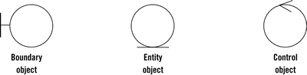

**Boundaries**  
Boundary class Objects communicate the information in a system to another system or with system actors (e.g. a human or a machine, a **user** or **external service**). Windows, dialogues, menu and communication classes such as TCP/IP are examples of boundaries that interface with users.

**Entities**  
Objects representing system data. The entity class object is used to model business objects (the core concepts), such as debt, invoice, insurance contract, and so on. They are typically persistent so that they can be stored in the system.

**Controls**  
Objects that mediate between boundaries and entities. These serve as the glue between boundary elements and entity elements. They are responsible for implementing the logic required to manage the various elements and their interactions, in other words they are responsible to handle a sequence of operations inside the system. It is important to understand that you may decide to implement controllers within your design as something other than objects – many controllers are simple enough to be implemented as a method of an entity or boundary class.

By including these three simple stereotypes, a class diagram can be made more precise and easier to understand for the reader. The purpose and responsibility of a class is indicated by its stereotype and is immediately visible in the diagram

**Four rules apply to their communication:**

1. Actors can only talk to boundary objects.
2. Boundary objects can only talk to controllers and actors.
3. Entity objects can only talk to controllers.
4. Controllers can talk to boundary objects and entity objects, and to other controllers, but not to actors

**Communication allowed:**

|  |  |  |  |
| --- | --- | --- | --- |
|  | **Entity** | **Boundary** | **Control** |
| **Entity** | **X** |  | **X** |
| **Boundary** |  |  | **X** |
| **Control** | **X** | **X** | **X** |

<https://www.youtube.com/watch?v=TAfccACvjXw>

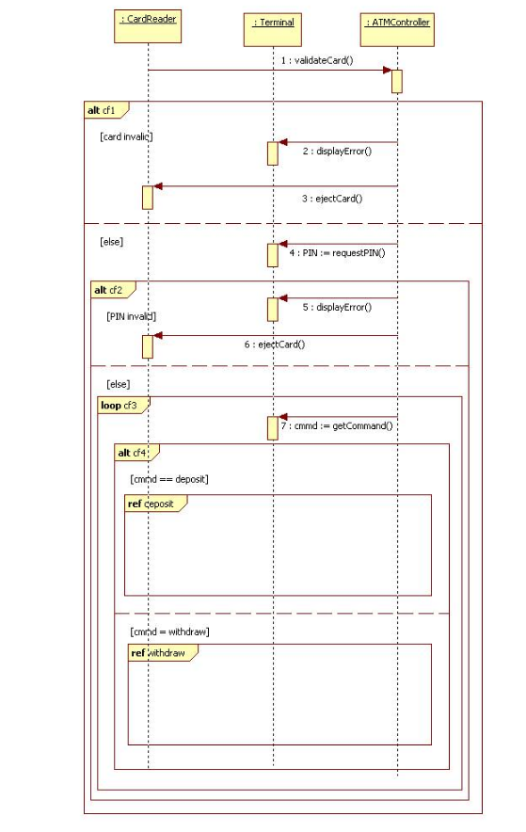

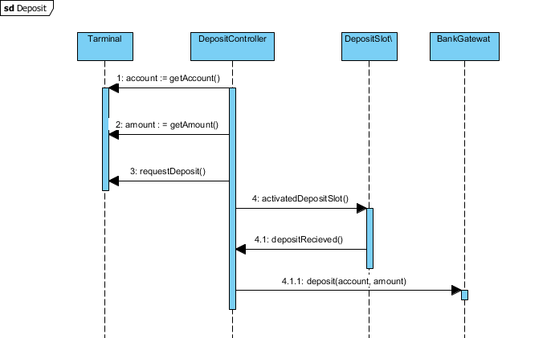

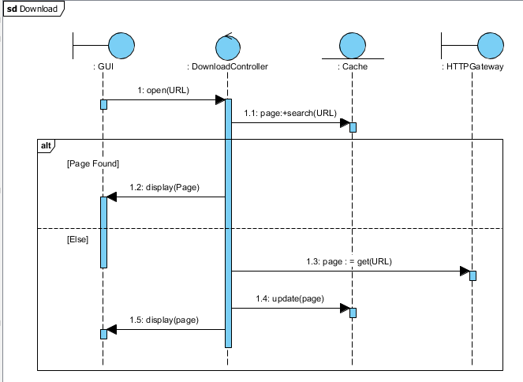

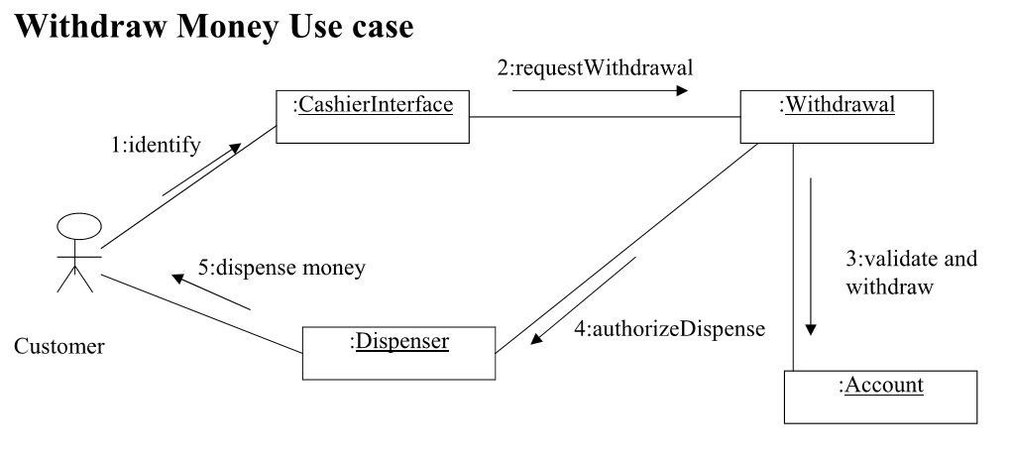

:Withdrawal

:CashierInterface

Customer

:RecieptDispenser

:Dispenser

:Account

:Deposit

Customer 🡪 cashier interface = identify

Cashier interface 🡪 request withdrawal